**MACHU PICCHU / GALAPAGOS ISLANDS**

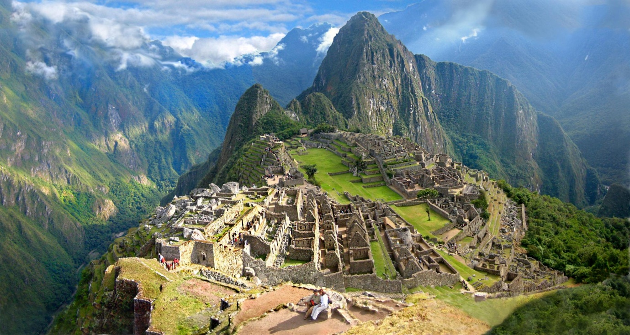

**Southern America Customizable Itinerary**

**(All itineraries are customized for each client)**

**Destinations at a glance:**

**Lima / Cuzco / Sacred Valley / Aguas Calientes / Huayna Picchu / Machu Picchu / Quito / Galapagos Islands**

**Itinerary Map**

<https://www.google.com/maps/d/edit?mid=zSCzYaeIhMGE.kyMFzoUbBGe4>

**DAY BY DAY ITINERARY 12 Days / 11 Nights**

**DAY BY DAY ITINERARY 13 Days / 12 Nights**

**DAY 1: Lima**

* Arrival in Lima and transfer to your hotel.
* Overnight in Lima for 2 nights at **Belmond Miraflores Park Hotel**.

**DAY 2: Lima**

* Lima City and Huaca Pucllana Tour: Private service / Duration: 4 hrs. / You will visit downtown area, Main Plazas, Presidential Palace, San Francisco Church and the Catacombs. Then, on to San Isidro District to see main residential neighborhoods and commercial areas. Continuing our tour to Miraflores District, You will visit Huaca Pucllana, one of the most ancient monuments in Lima. Finally, You will visit the Park of Love with great views of the Pacific Ocean.

**DAY 3: Lima - Cuzco**

* Transfer hotel - airport.
* Arrival in Cuzco and transfer to your selected hotel.
* Cuzco City Tour: Private service / Duration: 4 hrs. / You will visit downtown area, Main Plaza from where You will see the Cathedral. Then, Santo Domingo convent, Sacsayhuaman Inca Fortress, Quenco and finally, Tambomachay (Ceremonial Center).
* Overnight in Cuzco for 1 night at **Belmond Monasterio** Cuzco.

**DAY 4: Cuzco - Sacred Valley – Machu Picchu**

* Sacred Valley Tour: Private service / Duration: 8 - 9 hrs. / You will visit Awanacancha, Pisaq Ruins, Pisaq Market and Ollantaytambo Ruins. Lunch is included this day.
* Vistadome train Ollantaytambo - Aguas Calientes by Peru Rail [www.perurail.com](http://www.4m-express.com)

* Overnight in Aguas Calientes (Machu Picchu village) for 1 night at **Sumaq Hotel**.

**DAY 5: Machu Picchu – Cuzco**

* Climbing Huayna Picchu Guided service / Wake up early, get to the top of the mountain behind the Inca citadel in the classic photo of Machu Picchu and behold this marvel from above, a truly wonderful experience that you will never forget.
* Machu Picchu Tour: Private service / Duration: 2 hours. / You will visit main areas of the Inca Citadel such as ritual baths, the Palace of the Princess, the main Fountain and the Temple of the Sun.
* Vistadome train Aguas Calientes - Cuzco by Peru Rail [www.perurail.com](http://www.4m-express.com)

Departure: TBC

Arrival: TBC

* Transfer train station - hotel.
* Overnight in Cuzco for 1 night at **Belmond Monasterio** Cuzco.

**DAY 6: Cuzco - Lima**

* Transfer hotel - airport.
* Arrival in Lima and transfer to your selected hotel.
* Overnight in Lima for 1 night at **Belmond Miraflores Park Hotel**.

**DAY 7: Lima - Quito**

* Transfer hotel - airport.
* You will be welcomed at the airport and transferred to your hotel in Quito.
* Overnight in Quito for 1 night at **JW Marriott Quito Hotel**.

**DAY 8: Quito - Galapagos**

* Transfer hotel – airport for your flight to San Cristobal.
* **Cormorant (Stateroom**): 5 days - 4 nights / Group tours / Duration: mixed / Collection at the airport in San Cristobal and transfer to your selected vessel. (Overnight on board your vessel).

**DAY 9: Galapagos Islands**

* Activities in the Islands. Please see itinerary at [www.cormorantcruise.com/4-day-cruise.html](http://www.cormorantcruise.com/4-day-cruise.html)

**DAY 10: Galapagos Islands**

* Activities in the Islands

**DAY 11: Galapagos Islands**

* Activities in the Islands

**DAY 12: Galapagos - Quito**

* Collection from the port and transfer to the airport in Baltra.
* Arrival in Quito and transfer to your selected hotel.
* Overnight in Quito for 1 night at **JW Marriott Quito Hotel**.

**April 24, 2017 DAY 13: Quito**

* Colonial City Tour of Quito & Middle of the World Monument: Private service / Duration: 6 hrs. / Walk along the cobble stone streets in the Colonial Center and visit the Middle of the World Monument. Experience the unique magnetic pull of the equator.
* At agreed time, transfer to the airport for your flight home.

**END OF SERVICES**

**INCLUDED**

* Hotel nights detailed in the itinerary
* Breakfasts at all hotels
* Buffet Lunch in the Sacred Valley
* Tours and transfers
* Vistadome trains to/from Machu Picchu
* Entrance fees
* Travel Insurance
* One local cell phone to be in touch with our 24/7 Help line (Peruvian territory)
* Wet suits and snorkeling equipment on board the Cormorant/Ocean Spray
* Galapagos National Institute Migration Control Card: US$ 20.00
* Galapagos National Park Tax: US$ 100.00

**NOT INCLUDED**

* International airfare
* Lunches and dinners (Other than those mentioned above)
* Tips

**RECOMMENDED HOTELS**

**5 STAR**

**Lima**

Belmond Miraflores Park [www.belmond.com/es/miraflores-park-lima](http://www.belmond.com/es/miraflores-park-lima)

**Cuzco**

Belmond Monasterio Cuzco [www.belmond.com/es/hotel-monasterio-cusco](http://www.belmond.com/es/hotel-monasterio-cusco)

**Machu Picchu / Aguas Calientes**

Sumaq Hotel www.sumaqhotelperu.com

**Quito**

JW Marriott Quito www.marriott.com/hotels/travel/uiodt-jw-marriott-hotel-quito

You only recommend hotels and lodges that receive great reviews from our previous clients, as our recommendations to you reflect heavily on us. You suggest checking out all of the Youbsites listed here and perhaps taking a look at Trip Advisor for the comments of other travellers from around the world.

**By: D. VandenAkker**

**International Travel Specialist**

**Nakker International**

[**nakker4travel@gmail.com**](mailto:nakker4travel@gmail.com)

**(801) 277-3368**